Serpentine

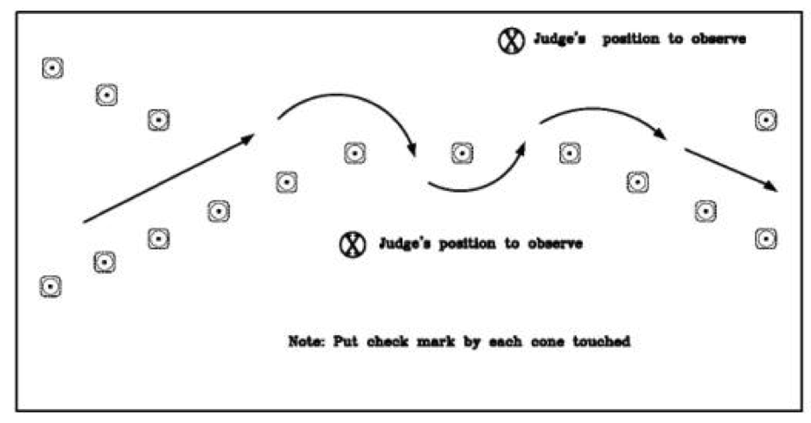

Pivot cone: 25 points

All other cones: 10 points
Offset Street

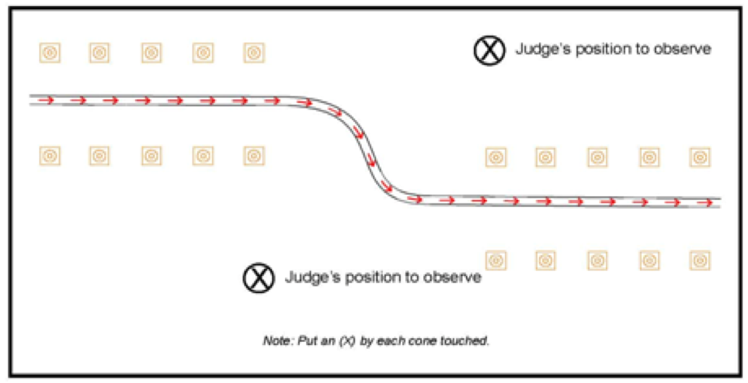

All cones: 10 points
Rear Dual Clearance

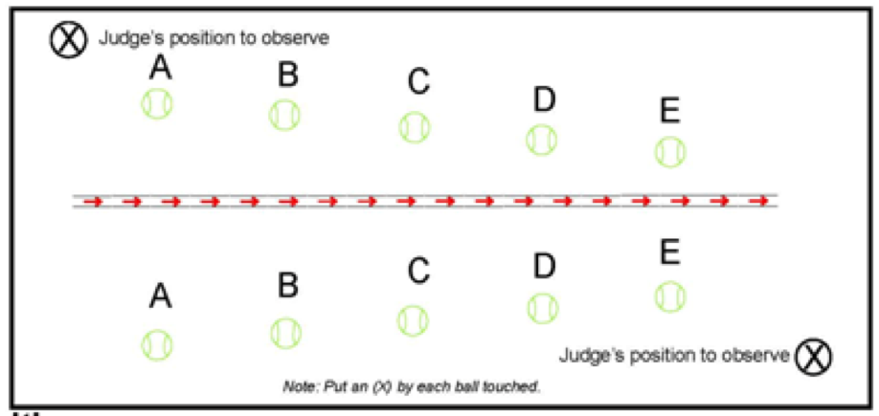

“A” ball: 20 points

“B” ball: 16 points

“C” ball: 8 points

“D” ball: 4 points

“E” ball: 2 points
Right Turn

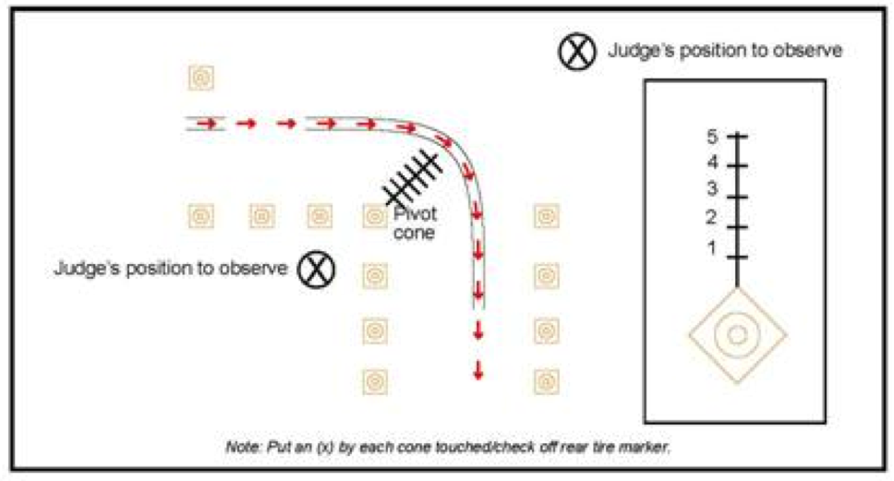

Pivot cone: 25 points

All other cones: 10 points

Right Reverse

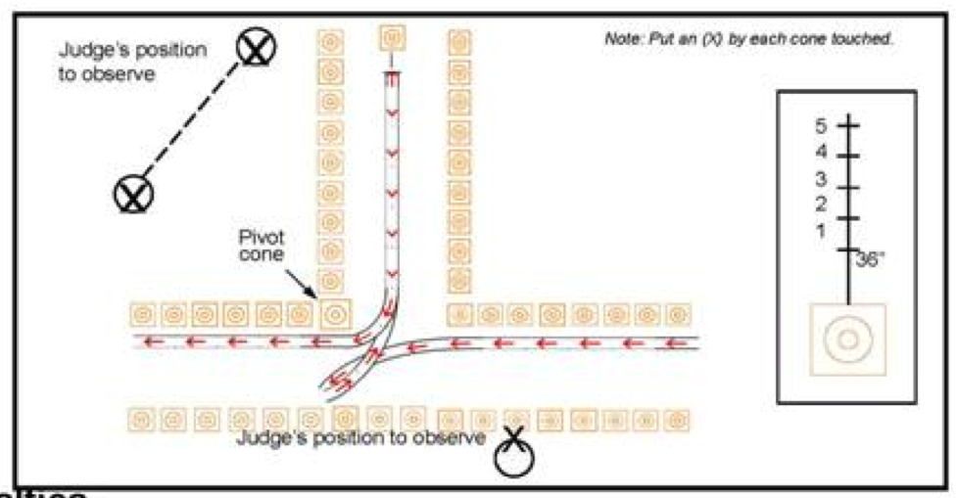

Rear cone: 25 points

Pivot cone: 10 points

All other cones: 5 points
Passenger Stop

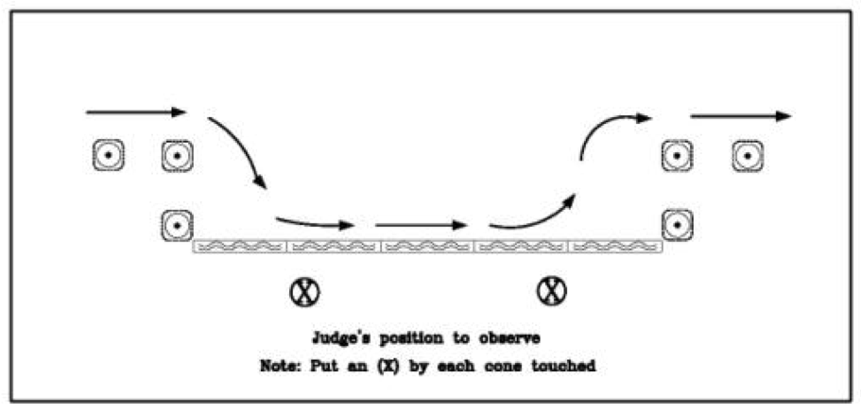

Any cone: 25 points

Any curb segment: 25 points
Left Turn

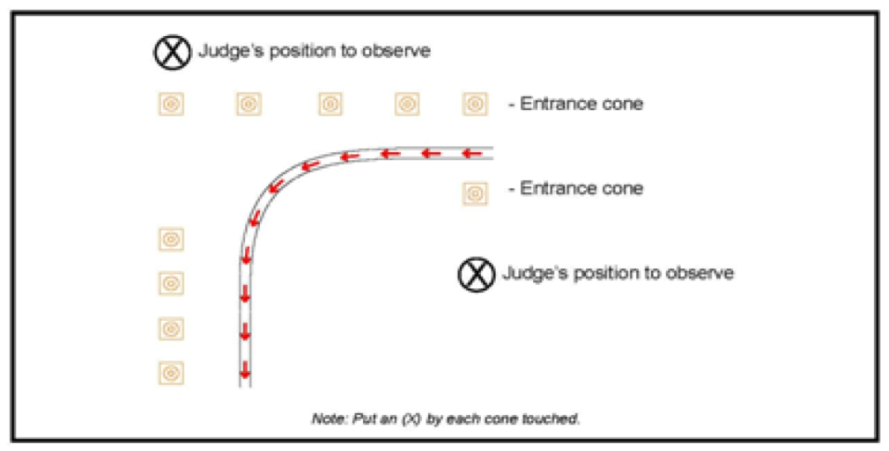

Entrance cone: 25 points

All other cones: 10 points
Left Reverse

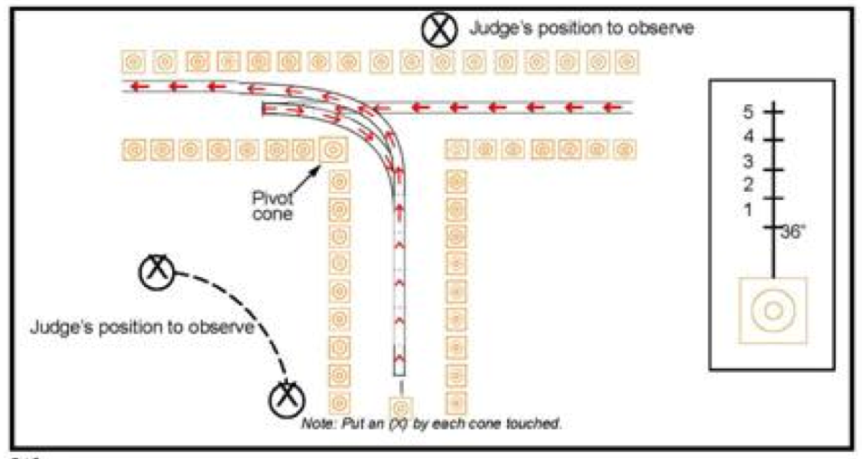
Rear cone: 25 points

Pivot cone: 10 points

All other cones: 5 points
Diminishing Clearance
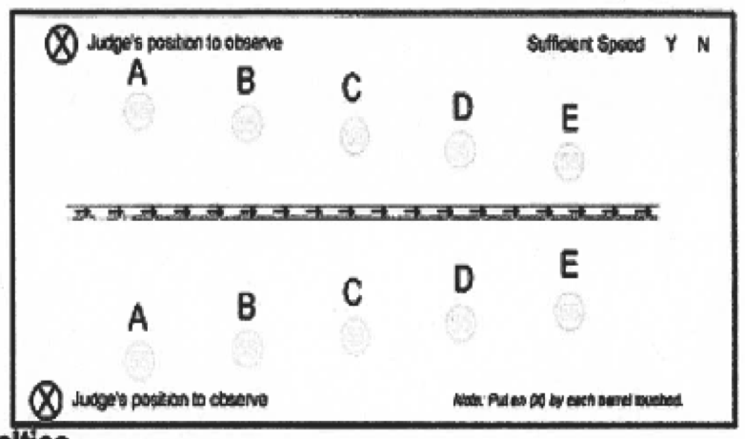
“A” barrel: 20 points

“B” barrel: 16 points

“C” barrel: 8 points

“D” barrel: 4 points

“E” barrel: 2 points
Judgement Stop

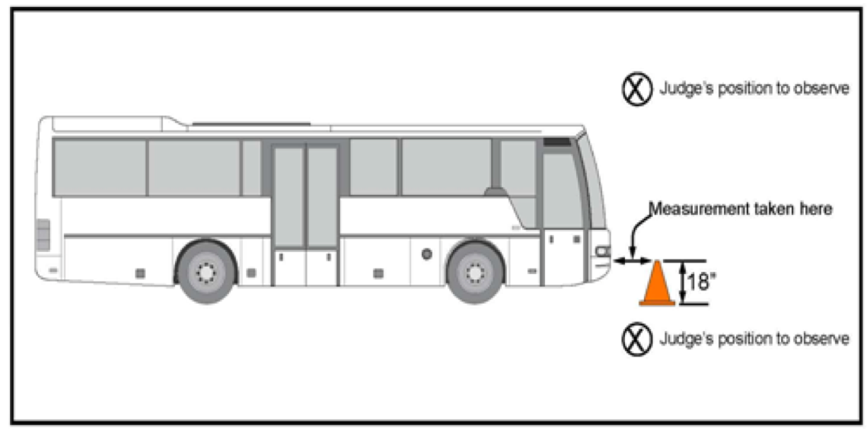
18” cone: 50 points

